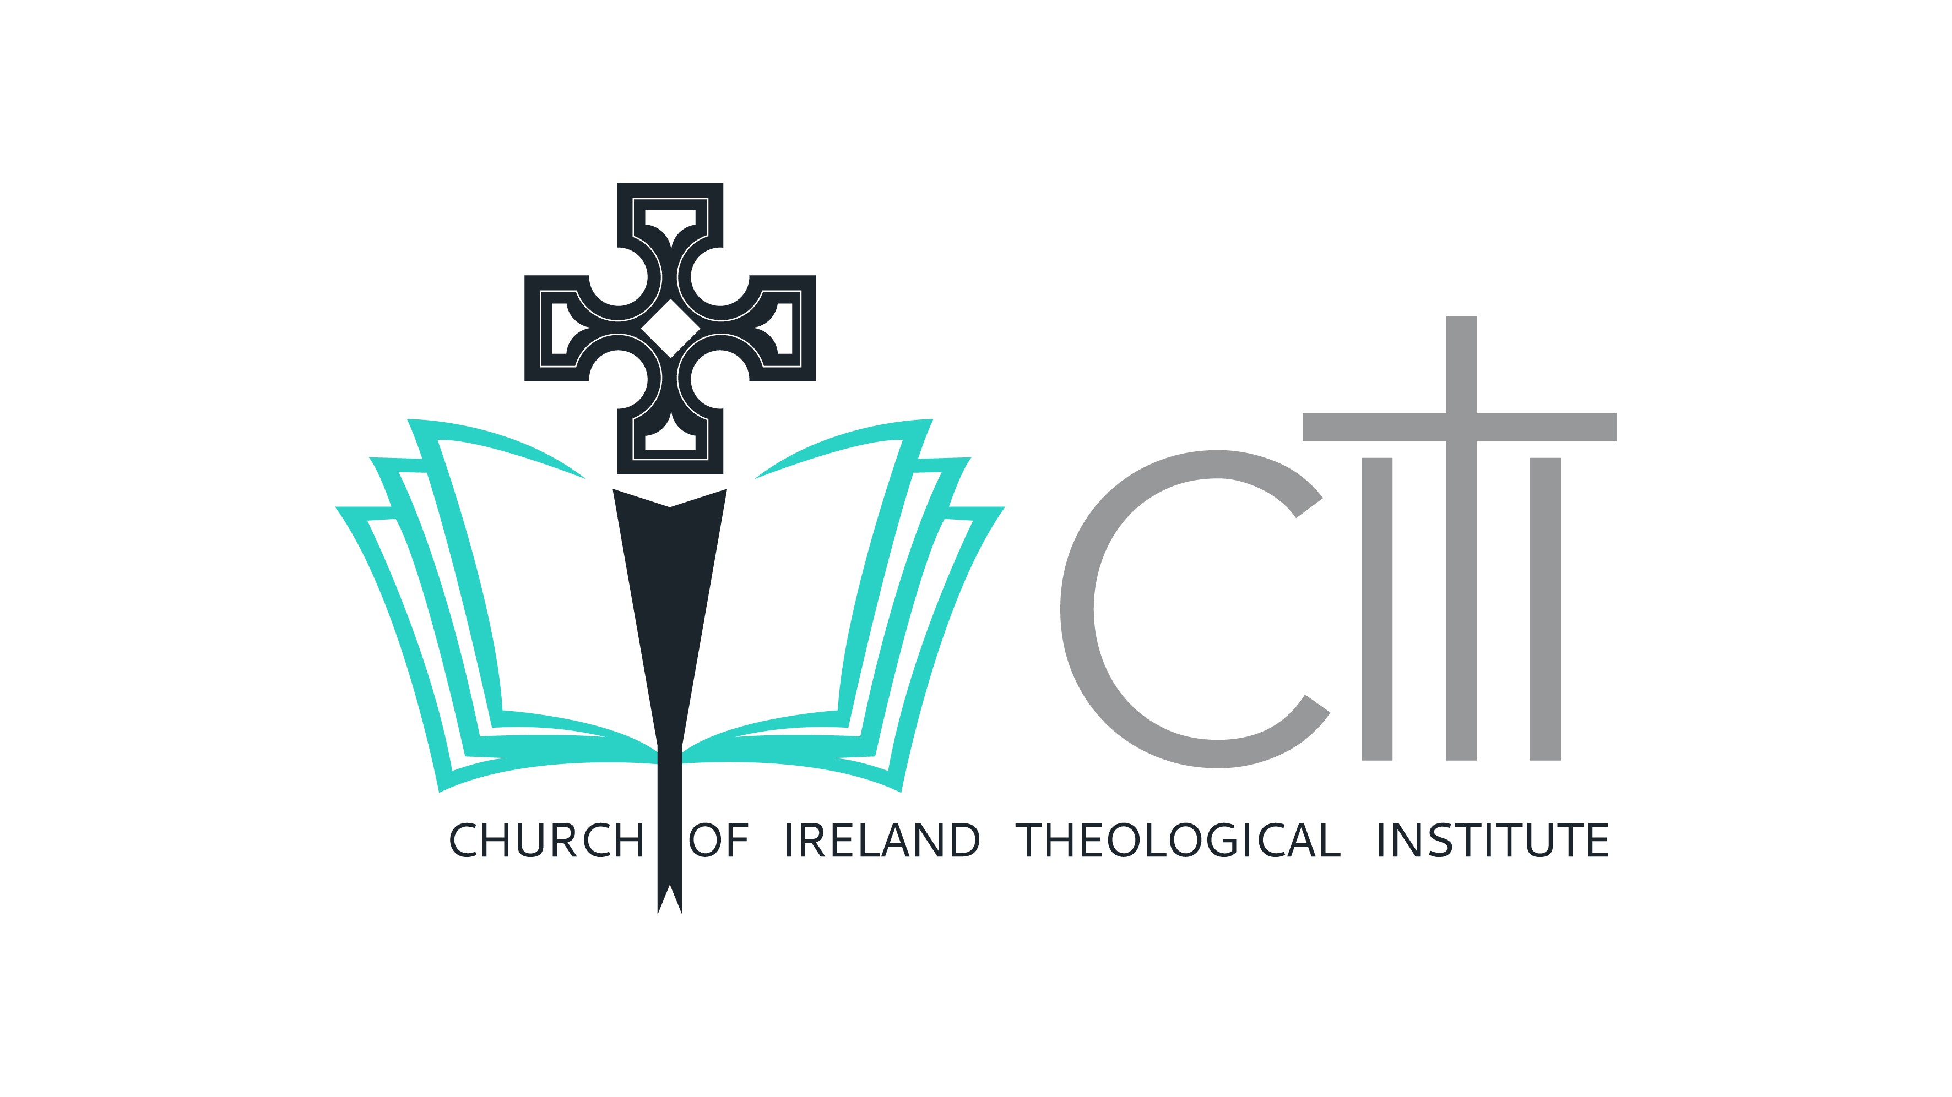
Certificate in Christian Theology and Practice Postal Application Form
(Please complete and return to: Church of Ireland Theological Institute, Braemor Park, Churchtown, Dublin, D14 KX24).
1. Name: _____________________________________________
2. Address: ___________________________________________
3. Email Address: ______________________________________
4. Contact Telephone Number:___________________________
5. Date of Birth: __________________________
6. I wish to undertake the programme for the following reason (please tick one):
- Adult Faith Formation – (please go to point 7)
- Church of Ireland Diocesan Reader Training.
  - Diocese: __________________

Please select from table below:
Diocesan Wardens of Readers
Diocese | Name | Please tick
Armagh | Revd Aonghus Mayes
Down & Dromore | Andrew Brannigan
Derry & Raphoe | Revd Canon Derek Quinn
Connor | Revd Peter Jones
Kilmore, Elphin & Ardagh | Revd Nick Jones
Tuam, Killala & Achonry | Very Revd Lynda Peilow
Dublin & Glendalough | Revd John Tanner
Meath & Kildare | Revd Alastair Graham
Cashel, Ferns & Ossory | Revd Barbara Fryday
Cork, Cloyne & Ross | Revd Paul Arbuthnot
Limerick & Ardfert | Revd Canon Liz Beasley
Killaloe | Revd Terry Mitchell
Clogher | Revd Paul Thompson

- Exploring Selection for Church of Ireland Ordination Training
  - Diocese: _______________
Please select from table below:
Diocesan Directors of Ordinands
Diocese | Name | Please tick
Armagh | Rev Canon WM Adair
Connor | Rev Canon Kevin Graham
Down & Dromore | Rev Simon Genoe
Down & Dromore | Rev Karen Salmon
Limerick, Killaloe & Ardfert | Rev Canon Elizabeth Beasley
Cashel, Ferns & Ossory | The Very Rev Paul Draper
Cork, Cloyne & Ross | Rev Peter Rutherford
Dublin & Glendalough | Rev Adrienne Galligan
Meath & Kildare | Rev Alastair Graham
Clogher | Ven Brian Harper
Derry & Raphoe | Rev Robert Boyd
Kilmore, Elphin & Ardagh | Rev Isaac Hanna
Tuam, Killala & Achonry | Rev Jennifer McWhirter

7. I am applying to audit the following modules only. I understand that if I select this option TCD credit is not included and I will not have access to the Virtual Learning Environment (VLE), but will have access to in-person and/or online live lectures.
- The ‘Fit for the Purpose weekend retreat’
- Encountering the Old Testament
- Encountering the New Testament
- Introduction to the Creeds
- Leading Public Worship
- Development of Theological Thinking
- Spirituality and Self-Understanding

8. Where did you hear about CCTP – please tick
Website
Magazine
Diocese
Other

9. Please attach a copy of your GCSE A Levels/ Leaving Certificate / or equivalent. If these cannot be located please include a copy of your degree certificate or any other academic qualifications.
If you have not completed A Levels/Leaving Certificate or any form of higher education, please indicate evidence of equivalent professional experience in the box below:

I understand that if I do not provide evidence of successful completion of A Levels/Leaving Certificate or equivalent professional experience I will be contacted to undertake an interview demonstrating my ability to benefit from and complete this course. Please circle YES / NO

As noted above, please attach a copy of any additional qualifications.

Degree/Certificate School/College/University Date
________________________________________________________________
________________________________________________________________
________________________________________________________________

10. Please certify your English Language Fluency:
- I am a native speaker of English
- I am attaching the results of my IELTS showing a score of 7 or greater.

11. The Church of Ireland Theological Institute will hold and retain the personal data contained in this application form in line with its data protection policy. In addition to this, the Institute would like your permission to contact you in relation to other courses, events or functions.
- I consent to CITI holding my contact details to contact me about related courses
- I consent to CITI holding my contact details to invite me to events and functions
- I consent to CITI to publish my image on the website and on social media

I hereby affirm that the information I have provided on this application is true and accurate to the best of my knowledge. I understand that this information has been gathered to enable a decision about my suitability for the course and is being retained by the Church of Ireland Theological Institute for this purpose and to facilitate communication with me.

Signature: ______________________________

Date:___________________________

