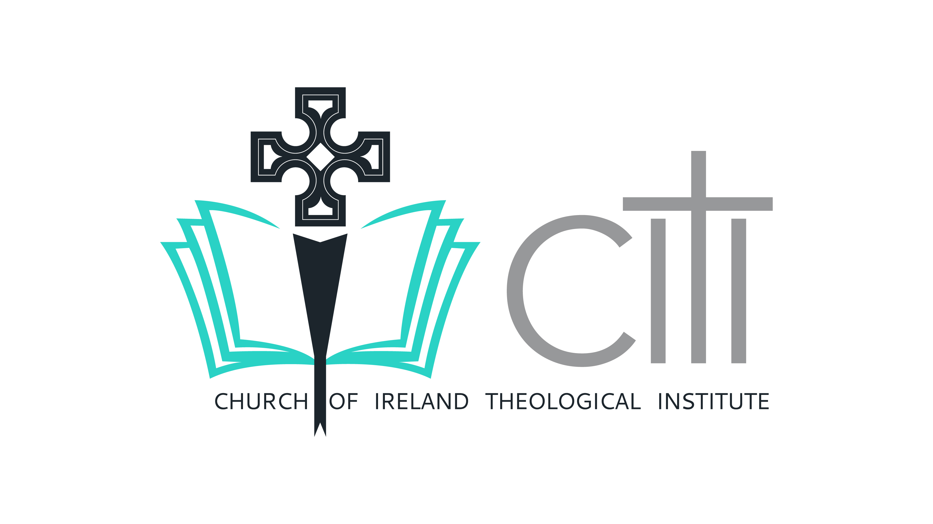
Certificate in Christian Theology and Practice Postal Application Form
(Please complete and return to: Church of Ireland Theological Institute, Braemor Park, Churchtown, Dublin, D14 KX24).
1. Name: _____________________________________________
2. Address: ___________________________________________
3. Parish: ____________________________________________
4. Email Address: ______________________________________
5. Contact Telephone Number: ___________________________
6. Date of Birth: __________________________
7. I wish to undertake the programme for the following reason (please tick one):
- Exploring Selection for Church of Ireland Ordination Training
  - Diocese: _______________
Please select from table below:
Diocesan Directors of Ordinands
Diocese | Name | Please tick
Central DDO | Very Rev Lynda Peilow
Armagh | Rev Ruth Murray
Clogher | Ven Brian Harper
Derry & Raphoe | Rev Canon Robert Boyd
Down & Dromore | Rev Simon Genoe
Down & Dromore | Rev Karen Salmon
Connor | Rev Canon Kevin Graham
Kilmore, Elphin & Ardagh | Rev Canon Ian Horner
Dublin & Glendalough | Rev Suzanne Harris
Dublin & Glendalough | Rev Tom O’Brien
Meath & Kildare | Rev Canon Alastair Graham
Meath & Kildare | Rev Ruth O’Kelly
Cashel, Ferns & Ossory | Very Rev Paul Draper
Cashel, Ferns & Ossory | Rev Nicola Halford
Cork, Cloyne & Ross | Rev John Ardis
Limerick & Killaloe | Rev Canon Liz Beasley

- Ordained Local Ministry
  - Diocese: _______________
Diocese | Name | Please tick
OLM Co-Ordinator | Rev Ken Rue | √
 | Patrick McGlinchey | √

- Church of Ireland Diocesan Reader Training
  - Diocese: __________________
Please select from table below:
Diocesan Wardens of Readers
Diocese | Name | Please tick
Armagh | Rev Gary McMurray
Clogher | Rev Paul Thompson
Derry & Raphoe | Rev Canon Derek Quinn
Down & Dromore | Rev Willie Nixon
Down & Dromore | Andrew Brannigan
Connor | Rev Peter Jones
Kilmore, Elphin & Ardagh | Rev Nick Jones
Dublin & Glendalough | Rev John Tanner
Meath & Kildare | Rev Canon Alastair Graham
Cashel, Ferns & Ossory | Very Rev Tom Gordon
Cork, Cloyne & Ross | Rev Paul Arbuthnot
Limerick & Killaloe | Rev Canon Elizabeth Beasley
Tuam | Very Rev Lynda Peilow

- Adult Faith Formation
CITI | Name
CCTP Course Co-ordinator | Revd Dr Patrick McGlinchey | √

- Auditing the Course

I am applying to audit the following modules only. I understand that if I select this option TCD credit is not included and I will not have access to the Virtual Learning Environment (VLE), but will have access to in-person and/or online live lectures.

- Encountering the Old Testament
- Encountering the New Testament
- Introduction to the Creeds
- Leading Public Worship
- Development of Theological Thinking
- Spirituality and Self-Understanding

8. Where did you hear about CCTP – please tick
Website
Magazine
Diocese
Other

9. Please attach a copy of your GCSE A Levels/ Leaving Certificate / or equivalent. If these cannot be located please attach a copy of your degree certificate or any other academic qualifications.
For those taking the pre-selection route it is mandatory that you attach copies of all degree certificates.

10. If you have not completed A Levels/Leaving Certificate or any form of
higher education, please indicate evidence of equivalent professional
experience in the box below:

I understand that if I do not provide evidence of successful completion of A Levels/Leaving Certificate or equivalent professional experience I will be contacted to undertake an interview to demonstrate my ability to benefit from and complete this course. Please circle YES / NOPlease list qualifications.

Degree/Certificate School/College/University Date
________________________________________________________________
________________________________________________________________
________________________________________________________________
________________________________________________________________
________________________________________________________________

10. Please certify your English Language Fluency:
- I am a native speaker of English
- I am attaching the results of my IELTS showing a score of 7 or greater.

11. The Church of Ireland Theological Institute will hold and retain the personal data contained in this application form in line with its data protection policy. In addition to this, the Institute would like your permission to contact you in relation to other courses, events or functions.
  - I consent to CITI holding my contact details to contact me about related courses
  - I consent to CITI holding my contact details to invite me to events and functions
  - I consent to CITI to publish my image on the website and on social media
  - I give permission for my final results from the CCTP to be
communicated to my sponsoring diocese through my DDO / WOR.

I hereby affirm that the information I have provided on this application is true and accurate to the best of my knowledge. I understand that this information has been gathered to enable a decision about my suitability for the course and is being retained by the Church of Ireland Theological Institute for this purpose and to facilitate communication with me.

Signature: ______________________________

Date: ___________________________

